**Chemistry 3D VR**

**Project Summary**

Our group built a protein modeling program for The Meiler Lab. The purpose of this program is to allow the user to grab two different proteins, one target, one ligand, and attempt to fit them together in a way that minimizes the Van der Waals forces of repulsion between, thus finding the optimal configuration for the proteins to bind. Within the game, there exist the two proteins, which are both grabbable, a scoreboard which displays the score based on the current configuration of the proteins, and a menu which allows several options such as hiding parts of the proteins, or toggling the labels. This program is meant to demonstrate how these two proteins interact with one another, and just how specific a configuration is required for binding.

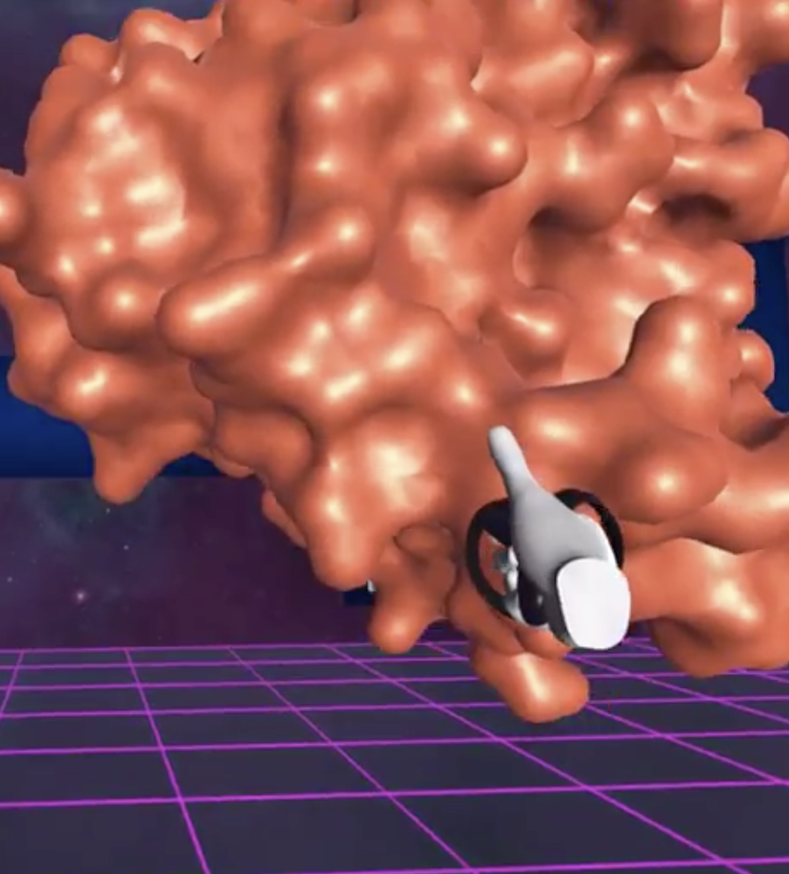

Both proteins are grabbable by reaching into their centers

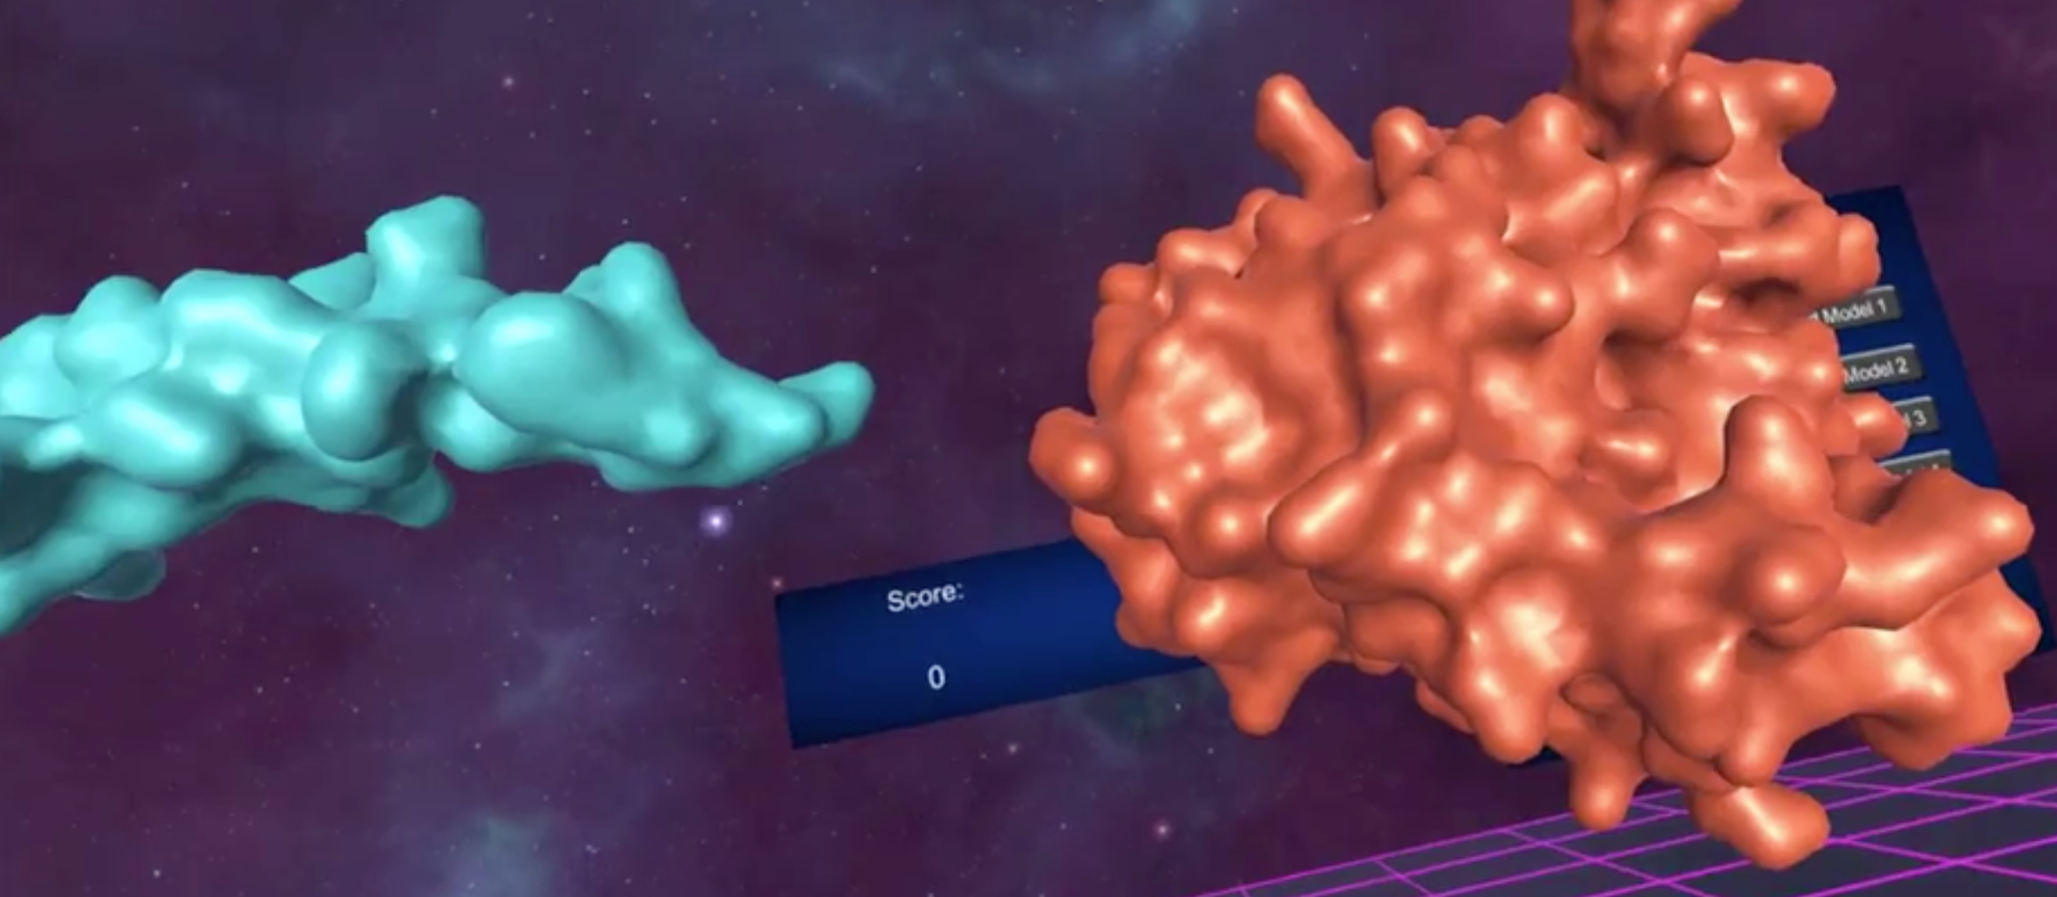

There are two proteins within the game, the ligand and the target

T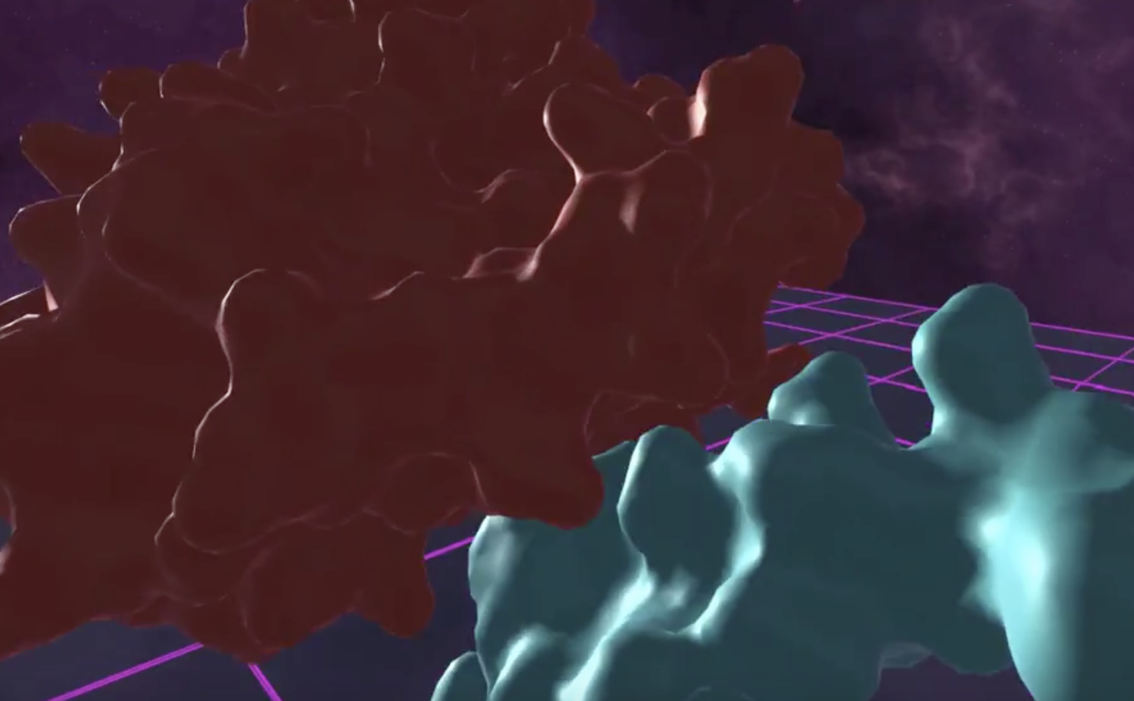The objective is to find the optimal configuration to fit the proteins together.

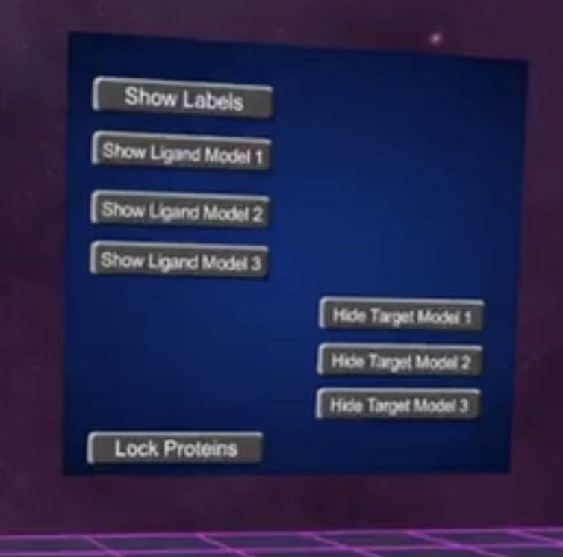

The menu selections allows for various settings such as toggling the labels, hiding/showing certain parts of the proteins, or locking them in place.

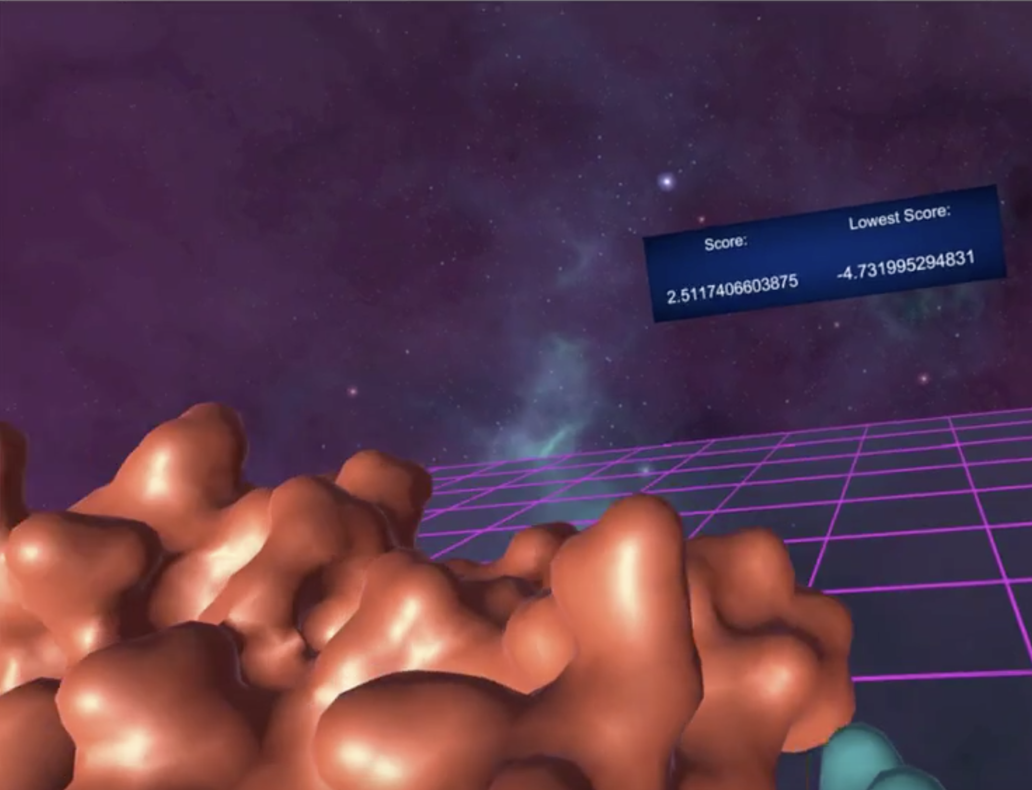

The score that displays is based on Van der Waals Equation, and it represents how close you are to the correct configuration. The lower your score, the less repulsion there is. Your goal is to minimize your score.